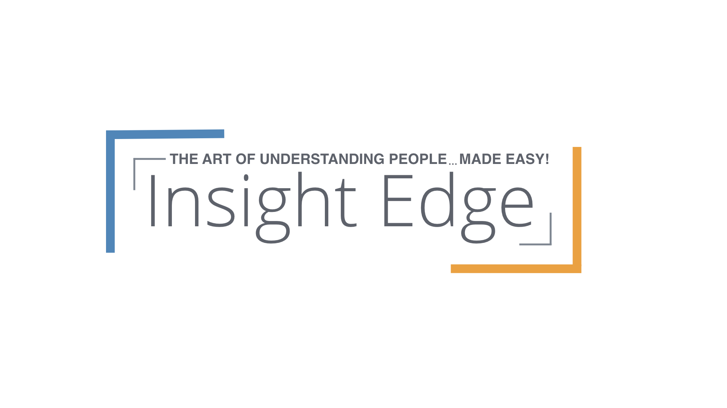

Session Details:

March 21, 1-5pm

Hilton Meeting Room B

123 Hotel Circle

Anytown, State, Zip Code

For more information contact:

Eric Moore

(317) 804-9440 - office

(760) 845-2827 - cell

ericmoore@insightedge.com

* With the aid of a customized, personal assessment, learn about your own communication pattern and how it is perceived by others.
* Learning about yourself will help to identify the pattern of those you know personally, those you work with, prospects you approach, and customers you presently have.
* Understanding patterns will greatly enhance your effectiveness in all areas of your personal and professional life.
* This is a very entertaining and informative session.

During this Practical Program, you will

* Discover how your specific communication and behavioral tendencies affect other individuals.
* Realize a respect, appreciation, and value for the communication expectations and differences of others – even when they are radically unlike your own!
* Develop strategies for easily identifying and effectively responding to the communication style preferred by different people.
* Learn how to understand, influence, and inspire others based on their preferences.

uncover a better way to interact with others!

**94% of Insight Edge training participants rate our courses "Better" or "Best" compared to previous training they have experienced!**

This session is entertaining and fast-paced. It provides you with real and practical skills that deliver immediate and long-term results. Added bonus: You'll receive a workbook and a customized personal assessment!

**The Art of Understanding People…Made Easy!**

Perfect for anyone whose success is connected with, and reliant on, getting along with “slightly irregular” people on a daily basis!